Changing a system:

-users don’t like change

-might lead to incompatibility(不兼容)

-people need time to get used to it.

Solution: change management

1. Plan: have a clear and valid reason to change certain parts.
2. Communication: communicate with stakeholders
3. Integrate: adjust the changes made to made a smoother transition
4. Evaluation: duh.

Legacy systems

Hardware: floppy disks

Software: Win XP

Computer system: Amiga

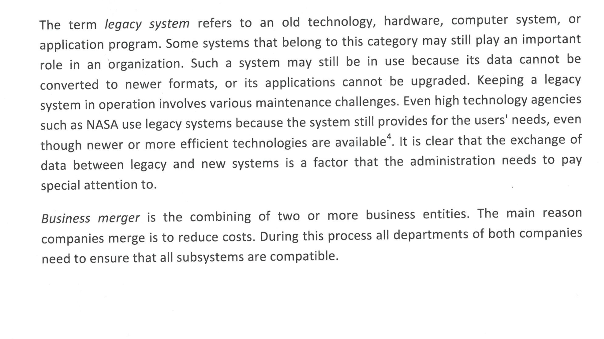

SaaS: Software as a service --- service served not on designed software but on external services like the web --- service providers are responsible for security, availability and performance.

Local software: